**Bùi Duy Anh_19H1040064_DV199CLC_KTPMUUD**

**Mã đề: 2**

**Câu 3**

SELECT a.cust_name AS "city",

a.city, b.commission

FROM customer a

INNER JOIN salesman b

ON a.salesman_id=b.salesman_id

WHERE b.commission>.10;

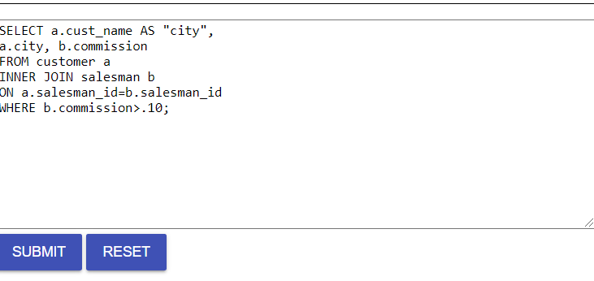

B)

SELECT a.cust_name AS "Customer Name",

a.city, b.name AS "Salesman", b.commission

FROM customer a

INNER JOIN salesman b

ON a.salesman_id=b.salesman_id

WHERE b.commission>.12;

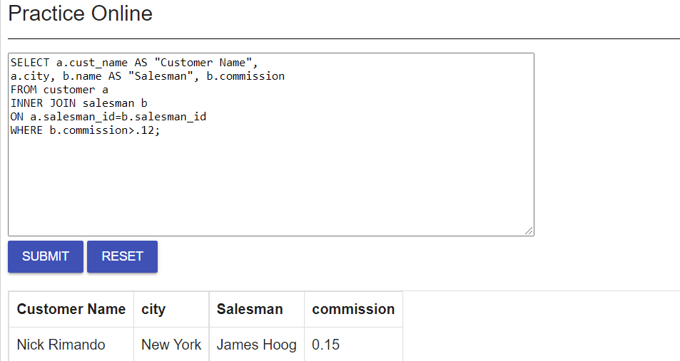

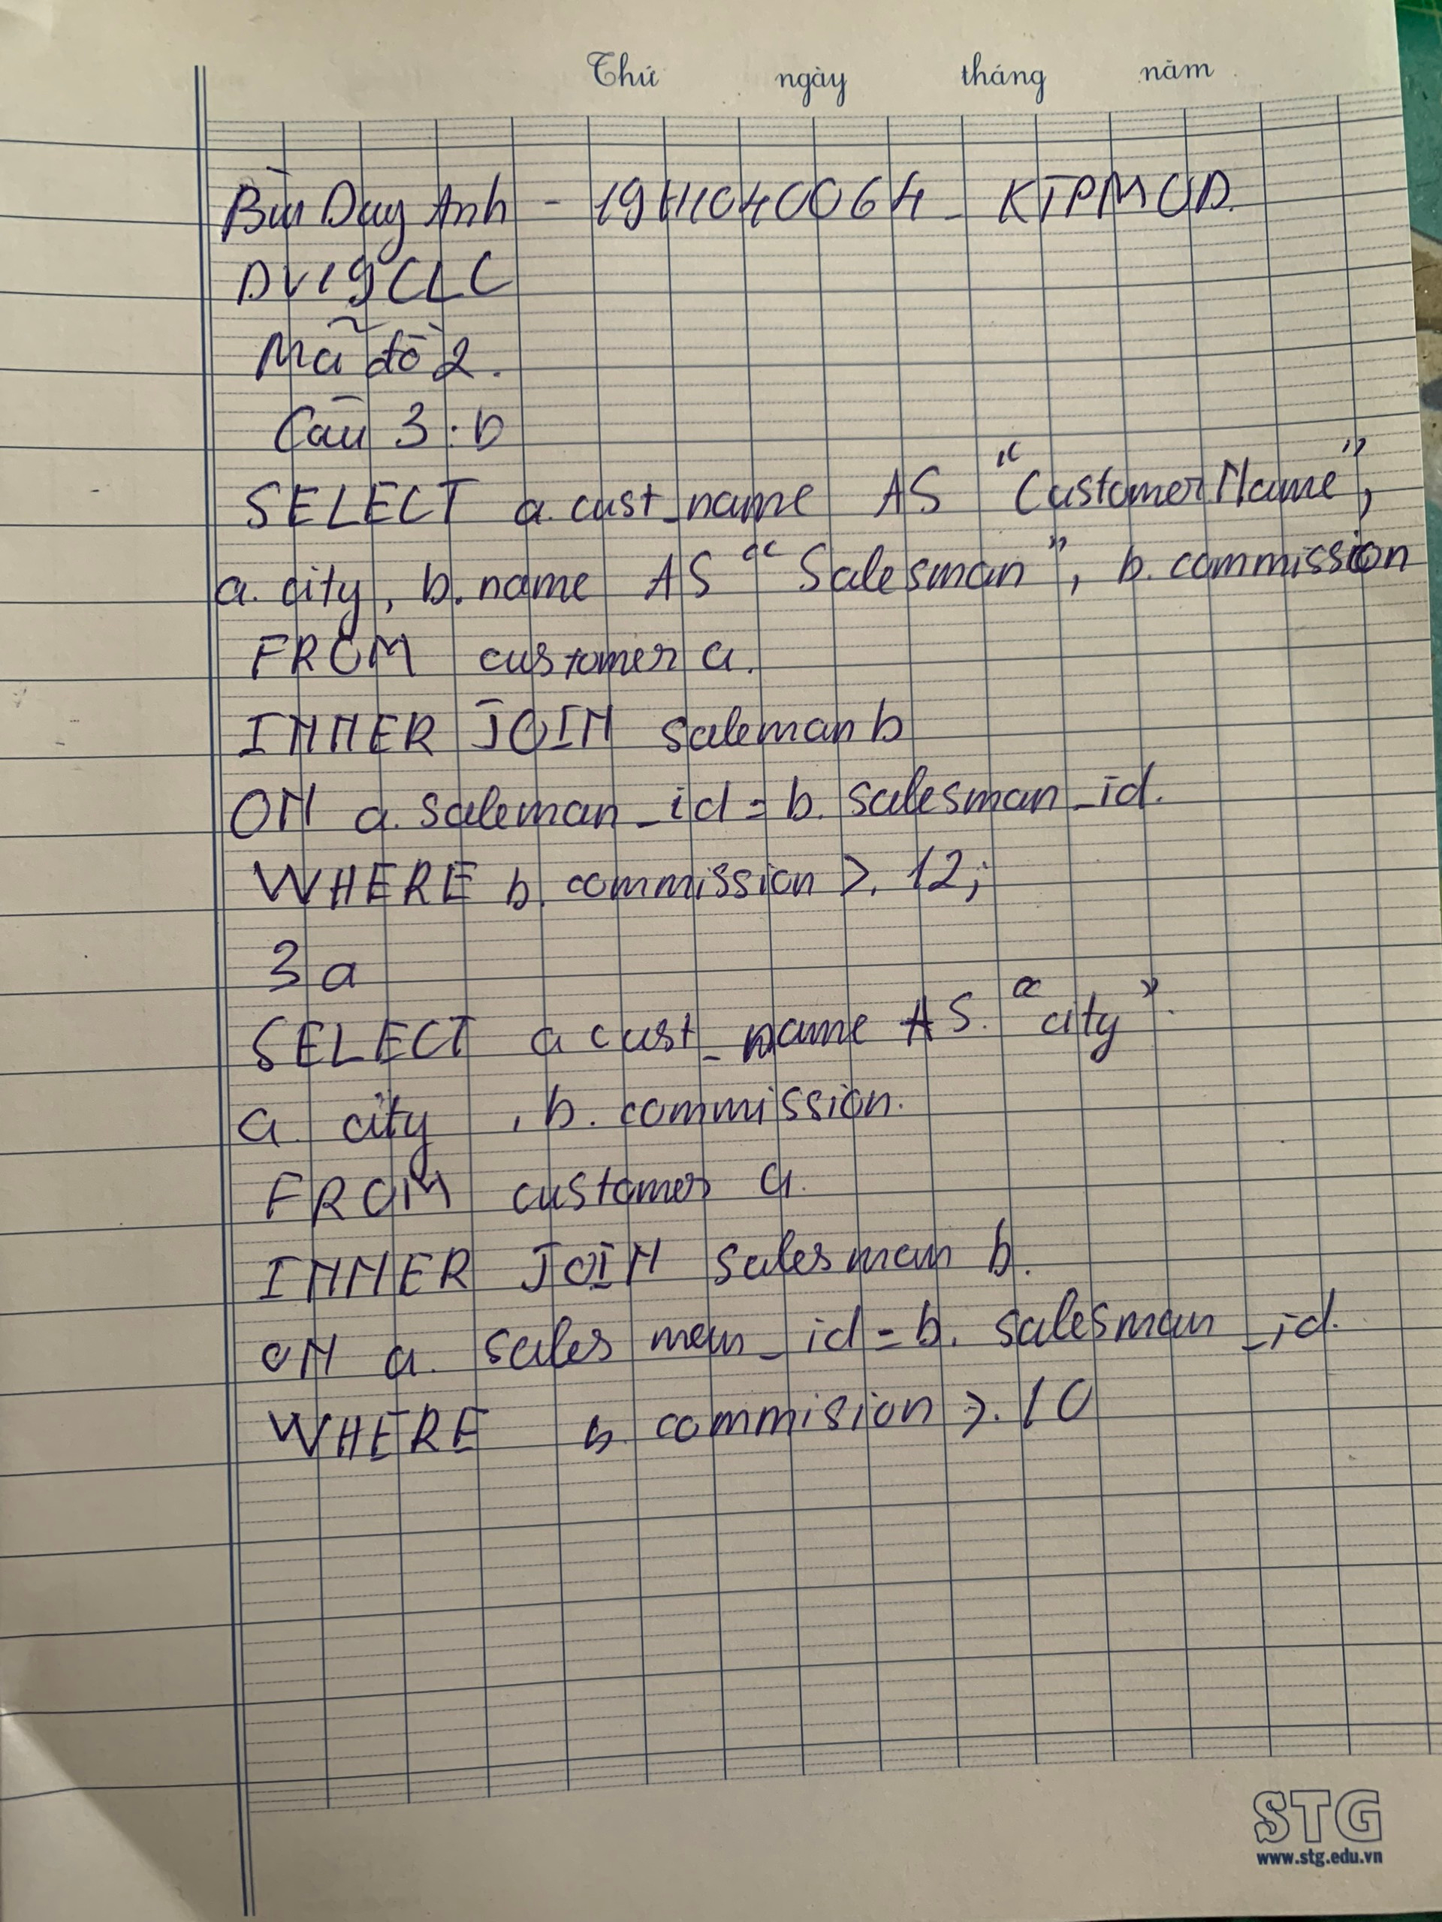

**Câu 1 a)**

def test_nhi_phan(a):

    if(a == '0000' or a== '0001' or a == '0010' or a== '0011' or a == '0100' or a== '0101' or

    a == '0110' or a== '0111' or  a == '1001'):

        return True

    else:

        return False

